**Course 2 Week 3**

Spreadsheets

* Organize Data
  + Pivot Table
    - Sort and filter data
* Calculate Data
  + Formulas
  + Functions

Data Life Cycle

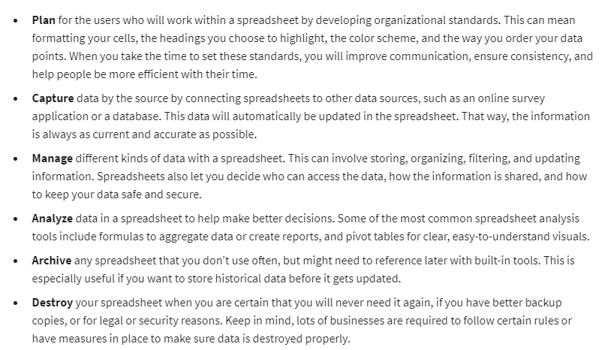

Formulas & Functions

Structured Thinking – Recognize the current situation, organize information, and identify options

Scope of Work – Boundaries of a project

Deliverables

Timeline

Milestones

Reports